DBMS – LAB -07

**NAME** : RAHUL VARMA

**ROLL NO**: S20200010212

**SECTION**: C

**TASK:** (LAB EXERCISES)

SQL COMMANDS:

Topic:

SQL procedures

1. Create a procedure to insert a tuple into any table of bank schema

Procedure:

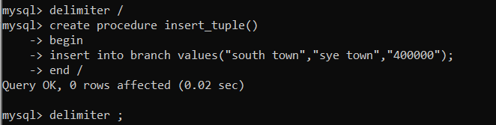

Contents in table before calling procedure:

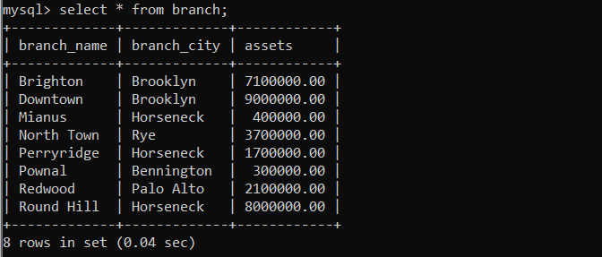

Contents in table after calling procedure:

(One tuple is added by procedure “south town”, ”sye town”, 400000.00)

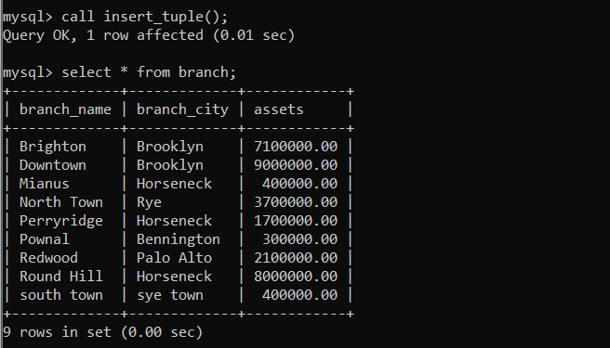

2. Drop the created procedure

Procedure for dropping table:



After dropping table again calling to check whether the procedure in present or not

(it should not present)

So we got error

So Successfully table dropped

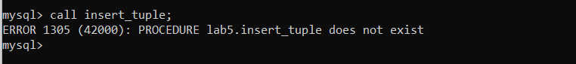

3. Create a procedure that takes any 2 numbers and returns their sum and

multiplication.

Procedure and calling procedure:

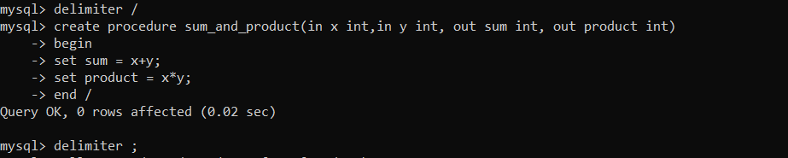

Calling procedure and printing the final answers:

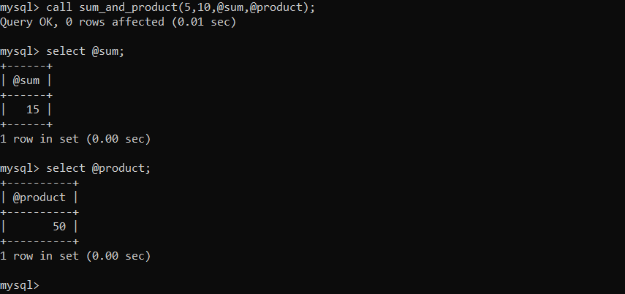

4. Write a procedure with only one parameter such that it returns the square root of any given number

Procedure:

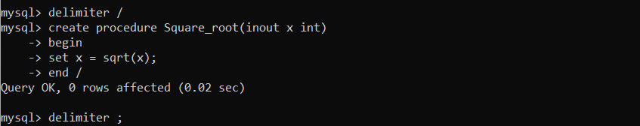

Calling procedure:

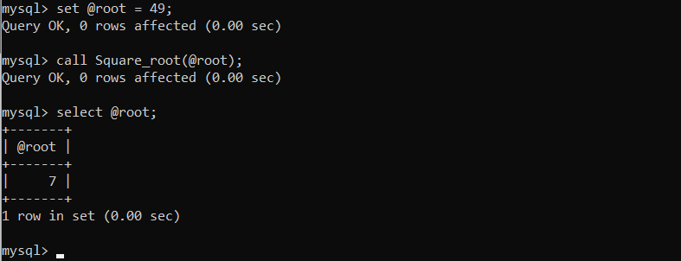

5. Write a Procedure that returns no.of characters in any given string

Procedure:

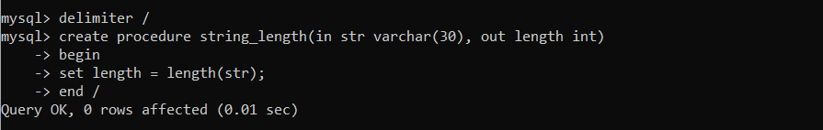

Calling procedure:

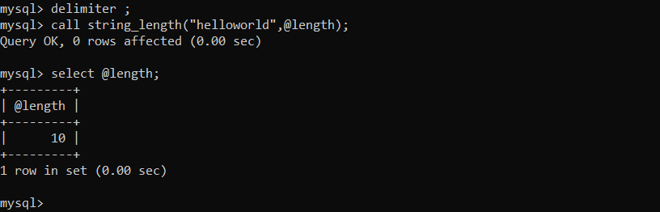

6. Write a procedure with only one parameter such that it displays the factorial of the given number

Procedure and calling procedure:

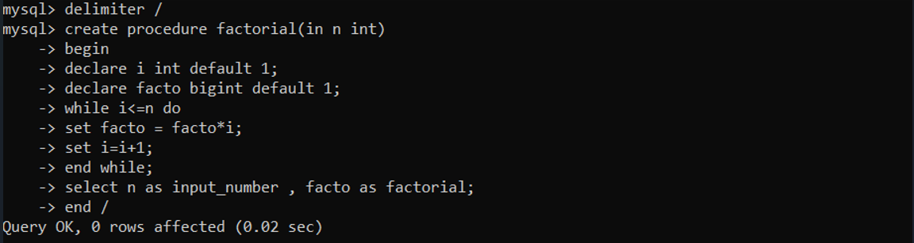

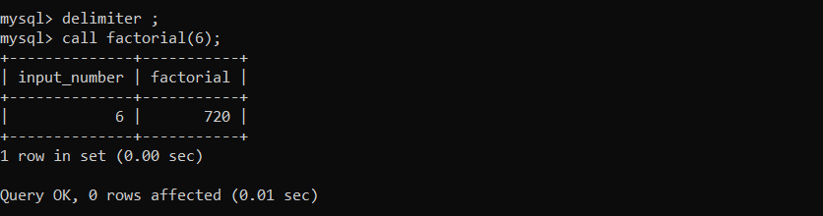

7. Write a procedure(that accepts 2 arguments,one argument has old name the other holds new name) to update name of the existing customer to a new name

Procedure:

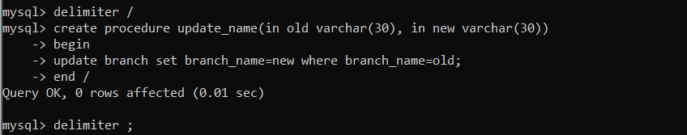

Content in branch before calling procedure:

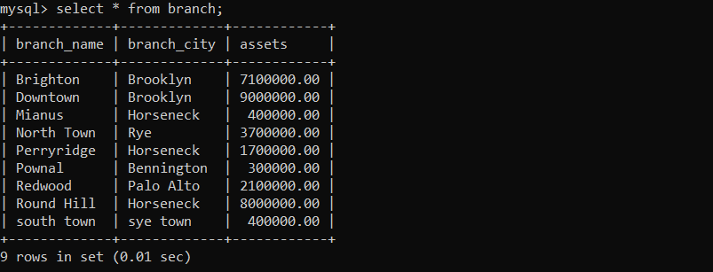

Content in branch after calling procedure:

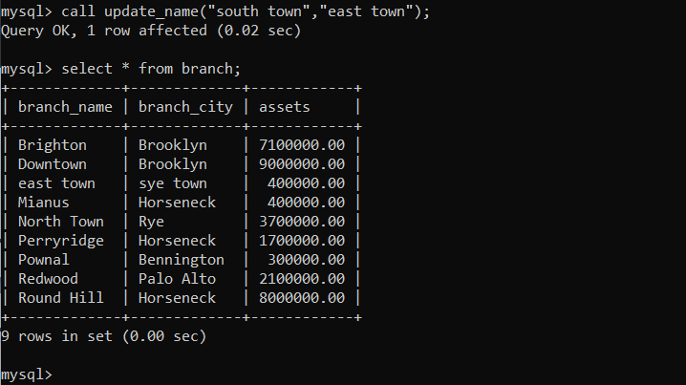

8. Procedure that accepts customer id and displays whether he has loan or Not

Procedure:

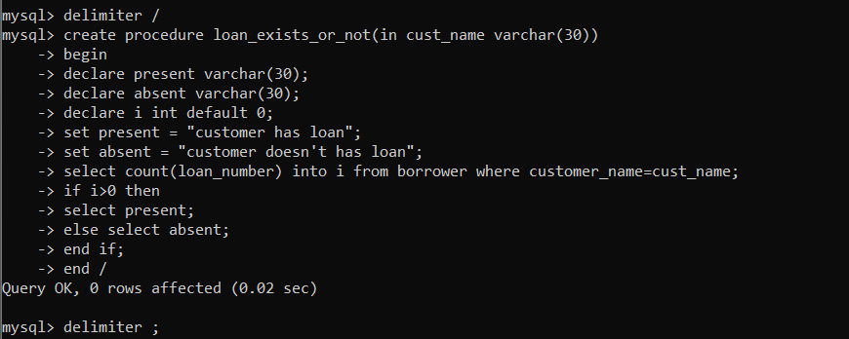

Content in borrower:

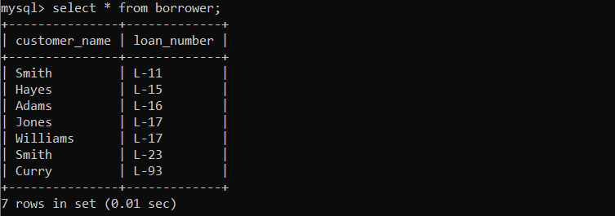

Calling procedure :

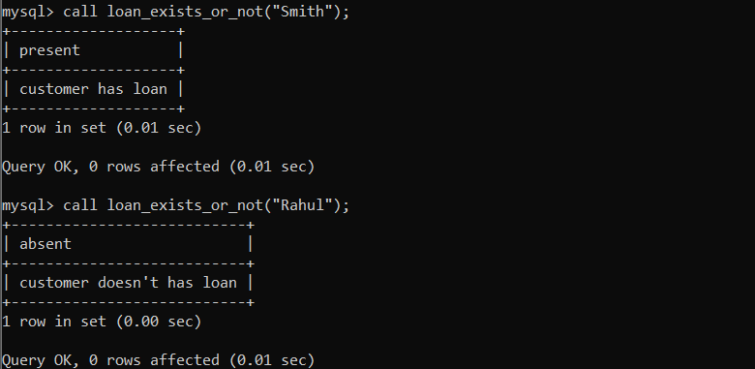

9. Display city of given customer and If he/she is not an existing customer

create a new entry in customer table

Procedure:

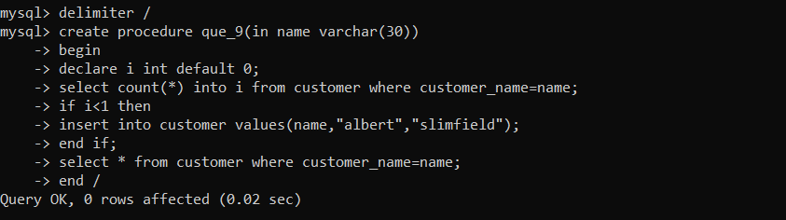

Content in customer table :

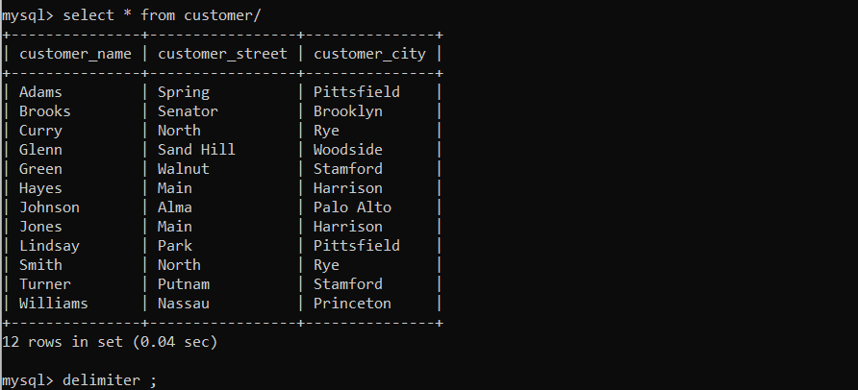

Procedure calling:

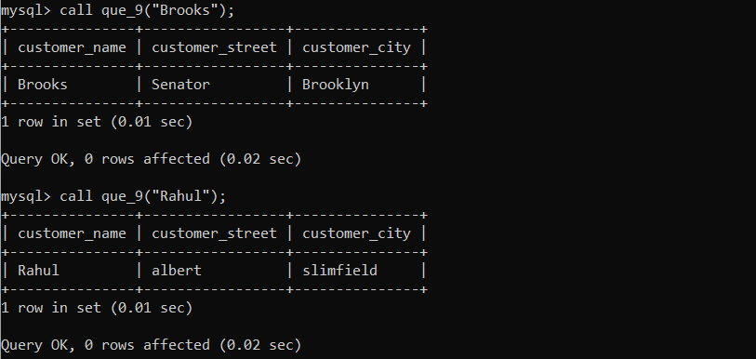

10. Display account numbers of customers whose balance is above the given Amount

Procedure:

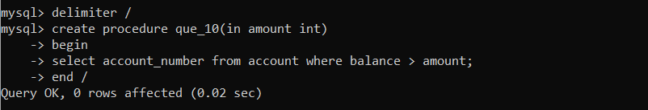

Procedure calling: (input with 700)

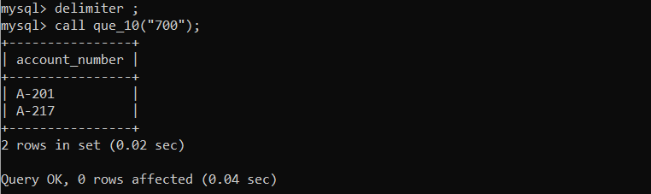

Procedure calling with input 500

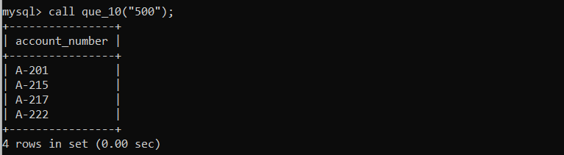

THANK YOU